“PQCRA”: Post-Quantum Cryptography Readiness Analyzer

- Problem Statement
Most current cryptographic systems have been designed with classical computers in mind and as a result will likely be vulnerable to the power of future quantum computers. To address this challenge, we need to build a system that can allow for automated analysis of existing algorithms to assess their robustness against quantum attack vectors to allow for a strategic transition of cryptographic systems.

- Introduction to Problem Statement
The area of quantum computing is advancing at a rapid pace and is expected to significantly affect the security measures currently used for cryptography. Many of today’s most commonly used cryptographic algorithms are based upon mathematical problems that are computationally infeasible to solve using classical computers. Consequently, the ability of quantum computers to solve these problems in a reasonable time frame has created an inconsistency between traditional security measures and future security measures.
Many organizations today do not have a clear understanding of which cryptographic algorithms exist within their systems or their level of vulnerability to quantum attacks. There are not many solutions available that can automatically analyze cryptographic implementations, determine their readiness for quantum cryptography, and identify vulnerability to quantum attacks. Manual analysis can be time consuming and labour intensive, requiring a high level of expertise, making manual analysis infeasible for larger organizations.
Given these challenges, an effective solution must be available that is easy to use, automated, and able to evaluate the security of cryptographic algorithms with respect to the impact of quantum threats. In this project, I will analyse currently deployed cryptographic solutions in order to identify weak or vulnerable cryptographic algorithms and assist organizations with the transition to post-quantum cryptography.

- Challenges:
There were a number of difficulties associated with the establishment of the PQCRA (Post Quantum Cryptography Readiness Analyzer) which reflect the tremendous difficulty associated with migration from classical to post-quantum based cryptographic systems.

Identifying Cryptographic Algorithms in Mixed Environments:
A primary hurdle exists in appropriately classifying cryptographic algorithms throughout various types of mixed environments, including source code, binary files, configuration files, and APIs, across a variety of operating systems, servers, hardware, etc.; and other differing formats (e.g., various ways a third party might choose to store/implement their code). Further complicating matters is the fact that there are usually no identifying marks indicating that an algorithm exists, so pattern recognition or heuristic techniques are typically used to establish possible algorithm matches but frequently result in inadequate matches or incorrect algorithm identification.
Lack of visibility into older systems and closed systems:
Many organisations implement older systems (legacy) or fully managed software solutions where the source code cannot be accessed; resulting in a lack of visibility/insight regarding how the underlying algorithms are secured/implemented. That creates a reliance on using indirect methods, including binary inspections and metadata analysis to identify how an algorithm was used, information about how keys were managed, etc.; none of which provide complete insight into how an algorithm was used.
Assessing quantum vulnerability level:
It is not necessarily easy to determine the security level of a given cipher against quantum attacks. An example of two widely-accepted methods that are known to fail against Shor’s Algorithm are RSA and ECC. A number of factors can affect how “risky” a cipher will be based on the key size, how it is implemented, how it will be used; therefore, determining the risk for individual ciphers based on these various factors, in order to arrive at a meaningful risk score, requires painstaking analysis and may still contain considerable variance.
Standardization of post-quantum algorithms:
The field of cryptography standards related to post-quantum cryptography continues to evolve; this includes efforts by organizations such as NIST to develop standardized methods. As new algorithms are developed and evaluated for performance and security, they are being documented; therefore, keeping information regarding the latest standards and recommendations may require an enormous amount of effort to ensure that inertia will not present difficulties in subsequently transferring or migrating them to a new format.
Scalability of performance limitations:
Analyzing large-scale systems with complex codebases can be challenging concerning scalability due to the volume of cryptographic components involved in evaluating potential cryptography systems. The overall cost of the scanning and review/potential risk, as well as the actual risks associated with different configurations, can create a large amount of computational load; therefore, optimizing your environment to accommodate enterprise-wide workloads without affecting the accuracy of the results is an overarching issue.
- Objectives
- To scan software source code, configuration files, and cryptographic assets to identify the use of classical cryptographic algorithms.
- To detect cryptographic algorithms that are vulnerable to quantum attacks, such as RSA and ECC.
- To assess the level of quantum risk based on algorithm type, key size, and usage context.
- To classify identified cryptographic implementations into risk categories such as Low, Medium, High, or Critical.
- To recommend suitable post-quantum cryptographic alternatives based on emerging standards and current research.
- To generate a structured post-quantum readiness report summarizing identified vulnerabilities and suggested migration paths.
The system will act as an early-stage decision-support tool, helping organizations understand their exposure to future quantum threats and plan cryptographic transitions in advance.

- Literature Review
Mohammed (2018) [17] was one of the first researchers to identify the potential for quantum computing to undermine the assurance of current digital systems' cryptography. The author highlights that most widely used cryptographic algorithms (i.e., RSA, ECC, and DH), which rely upon hard mathematical problems whose difficulty is calculated according to the model of classical computers; however, quantum computers will likely leverage superposition and entanglement to solve those same mathematical problems at an exponentially faster rate thus eliminating the cryptographic assurances provided by those algorithms. Furthermore, Mohammed notes that while symmetric cryptographic algorithms are somewhat protected against quantum attacks due to larger key lengths, practical limitations related to larger key lengths (e.g., storage limitations, increased computational requirements, and the cost of upgrading legacy systems) will limit the ability to use those symmetric cryptographic algorithms as a permanent solution.Building directly on this concern, Niederhagen and Waidner (2017) [18] reinforced the argument that increasing key sizes of existing classical algorithms is fundamentally insufficient as a response to quantum attacks, and called for an organised, coordinated transition toward post-quantum cryptographic alternatives across lattice-based, hash-based, code-based, and multivariate families, while stressing that this transition would not happen overnight and would require significant planning at both technical and organisational levels. Chen et al. (2016) [19], through the NIST IR 8105 report, provided one of the earliest formal institutional road maps for this shift, describing in detail how quantum computing undermines RSA and elliptic curve cryptography and outlining the necessity of quantum-resistant substitutes, though their performance assessments were based on preliminary data that does not fully reflect the capabilities of more recently developed post-quantum algorithms. Kan and Une (2021) [15] extended this line of analysis by examining the long-term structural threat posed by the continued development of quantum hardware, emphasising that even in the absence of large-scale fault-tolerant quantum computers today, the trajectory of quantum engineering creates a profound and unavoidable risk to existing cryptographic infrastructures that organisations must begin preparing for now, requiring coordinated effort, resources, and time to execute a gradual and controlled migration toward quantum-safe solutions. Kandula (2025) [2] brought this threat into the present-day context of web and mobile application security, arguing that popular public-key algorithms including RSA, DSA, and elliptic curve cryptography are built on mathematical assumptions that quantum algorithms — particularly Shor's algorithm — can effectively violate, and acknowledging that while the necessity of transitioning to post-quantum cryptography is clear, the path forward is complicated by implementation complexity and the performance overhead that quantum-resistant schemes introduce into existing application stacks.Gavin Seiler (2024) [5] similarly emphasises the need to transition to quantum-resilient cryptography and develop quantum key distribution methods immediately, pointing out that the public key infrastructures currently used by governments, financial institutions, and communications organisations are unprepared for the potential impact of quantum computers on their cryptographic infrastructures. Seiler indicates that it is essential to pursue both the adoption of quantum-resilient cryptographic techniques and the development of quantum key distribution methods in parallel to achieve meaningful, long-term security assurances against cyber attacks.
Dam and Tran (2022) [8] offered one of the more comprehensive and systematically organised treatments of the post-quantum cryptography landscape, classifying existing public-key protocols into five distinct families — lattice-based, code-based, hash-based, multivariate, and isogeny-based — and providing detailed discussion of the security foundations and implementation characteristics of each, alongside an overview of the international standardisation efforts led by NIST to identify and certify reliable quantum-resistant algorithms. While their work provides a sound theoretical foundation and comparative analysis across algorithm families, the authors did not include empirical benchmarking or analysis of real-world deployment scenarios, which limits its practical applicability. Dam et al. (2023) [10] revisited and extended this classification framework in a subsequent structured study, again organising post-quantum cryptographic techniques into lattice-based, code-based, hash-based, and multivariate families and examining how each addresses the growing threat of quantum attacks, though this work similarly fell short of providing practical deployment analysis or experimental validation, leaving an important gap between algorithmic theory and operational implementation. Neerav Sood (2023) [9] approached the same classification problem from a more applied perspective, identifying the same four major post-quantum algorithm families and arguing that these approaches collectively provide the tools necessary to secure future communications against quantum threats, while concluding that despite the real obstacles involved — including computational demands, integration complexity, and the need for standardisation — the adoption of post-quantum cryptography must be treated as an immediate priority rather than a future consideration, given that the window for proactive transition is narrowing as quantum hardware advances. Bagirovs and colleagues (2024) [4] took a look at different types of cryptography being used throughout multiple industries (banking, communication systems, and intellectual property protection) that provide evidence of the application of lattice, hash, code, multivariate, and isogeny based approaches being used either experimentally or at the early stages of implementation. In addition to identifying challenges with standardisation, high storage requirements, high computation requirements, and vulnerabilities that will only become apparent after years of analysing potential weaknesses or exploits, it is also important to note that risks from lack of quantifiable evidence can never be completely accounted for at the design stage. Kanza Cherkaoui Dekkaki and other authors (2024) [6] provided additional support for this classification effort by discussing their review of how post quantum cryptography is intended to secure current digital systems from potential quantum attacks, and that RSA and ECC will no longer provide long-term security due to the speed at which quantum computing is evolving. They also proposed a proactive (i.e. providing stakeholders with ways to assess/re-evaluate their current level of cryptographic security) and practical (i.e. establishing methods for addressing the transition to quantum-resistant technologies responsibly) framework that stakeholders can use as a guide through this process.
Dziechciarz and Niemiec (2025) [1] conducted one of the most direct and recent performance comparisons between post-quantum and classical cryptographic algorithms, analysing NIST-standardised post-quantum schemes across different programming environments and finding that certain post-quantum algorithms are capable of achieving performance comparable to or better than classical RSA in specific operational scenarios — a finding that challenges the commonly held assumption that post-quantum cryptography is universally slower and more resource-intensive than its classical counterparts. However, the authors acknowledged that their analysis did not examine hardware acceleration or energy efficiency in detail, leaving important dimensions of real-world deployment performance uncharacterised. Kumar performed a performance evaluation of various potential post-quantum cryptography algorithms using different criteria set by NIST. The criteria used for evaluating these algorithms were key size, memory size, and computational complexity (i.e what type of computations are needed to perform these algorithms). It was found that while many of these algorithms have been shown to provide an acceptable level of security against attacks that can be performed under the theoretical limits of currently available technology (and many of these could theoretically withstand attacks using infinite resources), they will not be used in operational environments today due to their very large key sizes and the additional computational overhead imposed by their implementation - particularly for systems where time is critical to performance, or those with limited processing capabilities.According to Opiłka and others in their article from 2024, the scope of benchmarking has been focused exclusively on digital signature algorithms; specifically, measurement of performance among CRYSTALS-Dilithium, Falcon and SPHINCS+ digital signature schemes using the liboqs library. The findings indicate that all three types of digital signatures can easily be incorporated into future communication networks (i.e., 5G and 6G) as well as indicating that a basic trade-off exists between execution time and securing level of each algorithm. Thus, it is important to take into account the trade-off mentioned above when deciding which algorithm to use for your specific deployment context; in general, algorithms which offer higher levels of security will require increased processing time to execute than lower level algorithms, which may lead to acceptance issues depending on your network environment.Kanza Cherkaoui Dekkaki et al. (2024) [6] reinforced the performance concern from a systems and policy perspective, arguing that the performance overhead of post-quantum schemes — while real and significant — must be weighed against the far greater long-term cost of maintaining cryptographic systems that quantum computers will be able to break, and providing a framework for organisations to begin this cost-benefit assessment in a structured and evidence-based way.
Roma et al. (2021) [14] focused on documenting the power dissipation of high energy consuming algorithms which are included in NIST's list of approved post-quantum cryptographic algorithms . They focused on evaluating this power consumption for the entire set of algorithms using an accurate measurement method. They found that many post-quantum algorithms consume considerably more energy to run than do their classical counterparts, thus making them more challenging to be used for practical applications. In addition, the authors observed that energy efficiency is not included in the NIST's formal criteria used to evaluate post-quantum algorithms for standardization purposes and identified this omission as a significant concern, especially for practical applications where products are powered by batteries or when running large-scale computing applications require a high-performance environment as well as for companies who practice environmentally responsible computing. The authors believe that the cost of energy to run post-quantum algorithms represents a significant barrier towards implementing post-quantum cryptography on a mass basis, particularly when applied in resource-constrained situations such as those with an IOT device, embedded systems, or Edge computing devices that all require tight control of their power budgets. Dziechciarz and Niemiec (2025) [1] touched on related concerns in their cross-environment performance study, noting that hardware-level considerations including acceleration and energy efficiency were left unexamined in their own benchmarking work — implicitly acknowledging the same gap that Roma et al. identified, and suggesting that a comprehensive performance picture for post-quantum algorithms in real-world deployment contexts remains an open research challenge. Fernández-Caramés and Fraga-Lamas (2020) [16] also encountered resource constraints as a central concern in their investigation of post-quantum cryptography for blockchain environments, identifying the compatibility of post-quantum schemes with resource-constrained nodes as one of three core integration challenges — alongside larger key sizes and increased computational overhead — that must be resolved before post-quantum cryptography can be practically deployed in distributed ledger systems at scale.
Horpenyuk et al.'s (2023) [7] study focused on the real-world impediments that an organisation may encounter while incorporating post-quantum cryptographic (PQC) algorithms into their current systems, which they identify as: 1.) large keys, 2.) interoperability issues with legacy systems, and 3.) inability to incorporate new cryptographic primitives into existing software stacks.They argue that even though these are legitimate barriers, the overall need to migrate to PQC as a viable means to ensure long-term cybersecurity in light of continued advances in quantum computer technology does not diminish.Käppler and Schneider (2022) [12] conducted their own study and analysed how organisations across various industries are confronting the technical, organisational, and operational challenges associated with replacing traditional encryption methods with PQC and what the intended guidance from the NIST standards process will provide to the transition.Both authors concluded that transitioning to PQC will take years, so immediate planning for this transition must begin now, rather than at the end of the standardisation process. Barker et al. (2021) [13] approached the migration problem from the institutional side through a NIST evaluation report, identifying early planning, thorough risk assessment, and the cultivation of crypto-agility — the organisational capacity to switch cryptographic systems without disrupting operations — as the three essential prerequisites for a successful transition to post-quantum cryptography. Importantly, however, the authors did not propose any automated mechanism by which an organisation could objectively evaluate its own level of transition readiness, leaving a practical tooling gap that subsequent work has not yet fully addressed. Bagirovs et al. (2024) [4] further contextualised these migration challenges within the broader landscape of industry adoption, noting that even in sectors where post-quantum techniques have seen early experimental deployment, the absence of completed standards, the high storage demands of certain algorithm families, and the risk of undiscovered vulnerabilities continue to slow progress and complicate enterprise-level adoption strategies.
Fernández-Caramés and Fraga-Lamas (2020) [16] conducted a targeted investigation into the vulnerability of blockchain and distributed ledger technologies to quantum attacks, concluding that quantum computers present a direct threat to public-key cryptography and hash functions, which underpin the integrity and consensus of almost all modern blockchains. The study progressed from identifying potential threats to comparing different post-quantum encryption schemes and digital signature schemes for their suitability in blockchain applications by evaluating performance overhead, key size considerations, and compatibility with the resource-constrained nature of blockchain nodes. The authors identified three main integration issues that need to be solved to make post-quantum cryptography viable in distributed ledger systems: managing the greatly increased key sizes that add to storage and bandwidth requirements; the increased computational overhead that will reduce transaction throughput and increase latency; and developing post-quantum solutions that will be compatible with the resource-constrained nodes commonly found in both permissioned and permissionless blockchain networks. Overall, the results of the study indicate that while the technical aspects of using post-quantum cryptography in a blockchain are possible, there is still significant engineering and protocol-level redesign needed before it can be used at scale without sacrificing the very performance and decentralization properties that are important to the value of blockchain.
Fisher et al. (2014) [20] addressed a distinct but complementary dimension of the quantum cryptography landscape — the question of how computation itself can be performed securely in a quantum environment — proposing a model in which a client prepares an encrypted quantum state and delegates the computational work to an untrusted quantum server, without ever exposing the original state, any intermediate measurement results, or the decryption key to the server. This approach ensures that the quantum server, despite performing the computation, gains no information about the data it is processing, with only the client able to recover the original state upon completion. Fisher et al. demonstrated the practical feasibility of this model through an experimental implementation using a photonic system, providing an early and important proof of concept for privacy-preserving quantum computation that has implications well beyond cryptography — including secure cloud-based quantum computing services, where clients may wish to leverage the computational power of a quantum server without trusting the server operator with sensitive data. This work stands apart from the rest of the literature reviewed here in that it does not focus on defending classical systems against quantum attacks, but instead begins to explore how quantum computation itself can be conducted in a trustworthy and privacy-preserving manner, representing an early step toward a broader framework of quantum-native security.

- Methodology
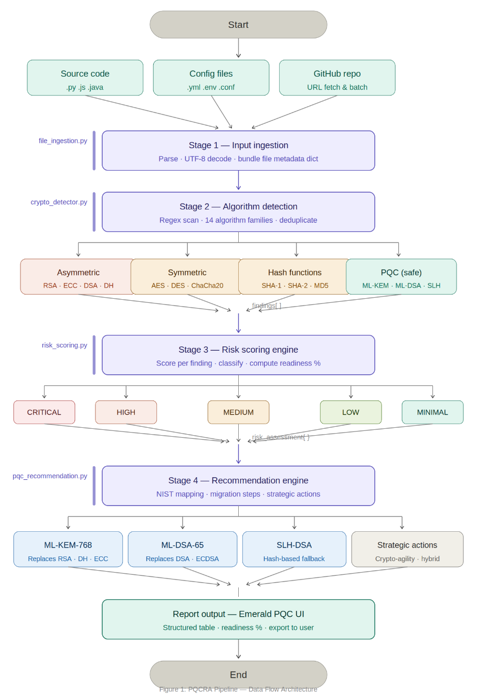
PQCRA follows a four-stage sequential MODULE, where each stage is a discrete module with a single well-defined responsibility, accepting structured input from the previous stage and passing structured output to the next. The tool accepts source code files, configuration files, or a connected GitHub repository as its input, and produces a structured post-quantum readiness report as its final output. The complete MODULE flows from file ingestion through algorithm detection, risk scoring, and recommendation generation, with each module independently testable and replaceable. The web interface, deployed on Vercel under the name Emerald PQC, serves as the front-end entry point through which users submit their code or repository for analysis and receive their readiness results in a structured tabular format.
Figure 1: PQC- Data Flow Architecture

Figure 1: PQCRA — Data Flow Architecture
  - Core Modules
6.1.1 Input Ingestion and File Parsing
At the beginning of the PQCRA MODULE, the user submits either a pasted code buffer, an uploaded source file, or a connected GitHub repository URL through the user interface; this submission is validated by the system to ensure that it is non-empty and of a supported format, before it is submitted to the Detection Stage. Each type of file submits their "raw" text content after being parsed and, in the case of byte encoded files, processed into a UTF-8 representation with error handling to prevent the MODULE from stopping due to a file containing binary or non-standard data. Information about each file, including the file path, the name of the file and inferred type, will be bundled into a file information data structure as a means to pass on to the Cryptographic Detector, which will allow all subsequent modules in the MODULE to be provided with input data of a consistent structure regardless of how the input data was formatted, and to reject malformed or unsupported input data as early as possible in the process.
6.1.2 Cryptographic Algorithm Detection
The second stage of processing involves receiving the file content from the previous stage and scanning it for any type of cryptographic algorithm identifier using a complete library of regular expression patterns defined in the crypto_detector.py file. This part of the detector will keep a comprehensive dictionary of identified patterns consisting of 14 different families of algorithms broken down into four broad categories: post-quantum, public (asymmetric), symmetric, and hash algorithms. There are four classes of algorithms that have various surface-level patterns assigned to them. A good illustration of this can be found from the way the detector searches for RSA type Algorithms. The detector searches on the following terms: RSAPublicKey, RSAPrivateKey, RSA_PKCS1, rsa_sign, RSA/ECB, RSAES, and RSASSA. These will enable the detector to locate any of the different algorithm variations that exist regardless of the names they are found by or whether they are called API identifiers impacted by the programming language or development framework used for implementation. Likewise, once a match is found, the detector also provides the name of the matched algorithm, file location and line number where the match appears, the surrounding code (100 characters on either side of the match), whether or not the matched algorithm is quantum vulnerable and what the related quantum attack vector is, and the category of the matched algorithm. In addition, this stage attempts to derive a key size associated with each match / detection by scanning the surrounding context of the match for declarations or other common values (e.g., 1024, 2048, 4096, 128, 256, 512) of key sizes. Finally, at the end of this stage, a deduplication will occur to remove instances of the same algorithm being matched multiple times within the same file over a relatively close proximity of each other; in effect decreasing the total number of vulnerabilities detected using the same implementation.Each confirmed finding is added to a structured findings list that is passed to the risk scoring stage.

6.1.3 Risk Scoring Engine
The third step of this process is to receive the list of crypto-related vulnerabilities and then run those findings through a risk evaluation to determine the risk of each discovery aspect through the use of the risk_scoring.py codebase. When evaluating each finding that showed a potential vulnerability to quantum computer attacks, scoring will utilise various factors to generate a score for those findings, including, where applicable, the algorithm class/type, the key length, and the threat associated with the algorithm against typical methods of quantum attacks. Once the score is produced for a given finding, it can be categorized into five levels of potential risk (e.g. a "CRITICAL" finding would classify as the highest level risk). In addition to individual risk evaluations of the identified crypto vulnerabilities, the overall risk associated with the entire codebase is determined based upon the distribution of risk ratings of each finding. A CRITICAL-level finding in any form or of any type will provide a CRITICAL-level risk rating for the entire scanned codebase, whereas the entire scanned codebase would receive a HIGH-level risk rating if there is at least one HIGH-level risk finding present within the scanned codebase or if the average risk rating of the evaluated findings is at least or above 65. The overall readiness rating of the scanned codebase will be determined by subtracting the overall risk rating from 100 and all overall readiness ratings will be limited to a score between zero and 100.Beyond numerical scores, the engine generates a prioritized action list tailored to the finding distribution — for example, a codebase with CRITICAL findings triggers an immediate recommendation to replace public-key implementations and address the harvest-now-decrypt-later threat, while a codebase with only MEDIUM findings receives medium-term migration guidance and a directive to evaluate NIST PQC standards. The complete risk assessment dictionary — including overall level, score, finding counts by severity level, readiness percentage, priority actions, and algorithm inventory — is passed to the recommendation engine.
6.1.4 PQC Recommendation Engine and Report Generation
In Stage 4, the Risk Assessment and complete list of vulnerability findings are received, and with the assistance of pqc_recommendation.py, a structured set of migration recommendations is generated from those findings. All vulnerability findings are ranked by descending order of Risk Score, so the most critical vulnerabilities receive first said recommendations. For each vulnerability finding, the engine matches the detected algorithm to a suitable (approved by NIST) post-quantum-algorithm replacement. As a result, RSA/DH encryption usages are replaced with ML-KEM-768 (NIST FIPS 203; 2024); DSA/ECDSA signature usages are replaced with ML-DSA-65 (NIST FIPS 204; 2024); already obsolete algorithms such as SHA-1, MD5, and DES receive immediate replacement recommendations regardless of quantum-related risks; and any AES usages that employ a keysize less than 256 bits have been flagged for key size upgrade. Each recommendation includes the current algorithm; recommended post-quantum replacement algorithm; justification/rationale for migration; priority (P0 - P4); and a series of concrete migration steps, including Library Selection; Testing; Hybrid Deployment; and Rollout.For codebases assessed at CRITICAL or HIGH overall risk, the engine additionally generates four strategic organizational recommendations covering the formation of a PQC migration task force, the implementation of crypto-agility through abstracted cryptographic interfaces, the adoption of hybrid classical-PQC approaches during the transition period, and the update of certificate infrastructure to support PQC certificates. The complete findings, risk assessment, and recommendations are serialized and rendered in the Emerald PQC web interface as a structured table organized by file location, algorithm, quantum risk level, and post-quantum mitigation framework, giving the analyst an immediately actionable overview of their organization's post-quantum readiness posture.
6.1.5 Report Output
The fifth and final stage receives the complete analysis output from the recommendation engine and renders it as a structured, human-readable readiness report through the Emerald PQC web interface deployed at minor-project-sepia.vercel.app. The report is organised into a structured table with four columns — Location/Trace identifying the file and line number of each finding, Mathematics describing the algorithm and its cryptographic basis, Quantum Risk displaying the assessed risk level and score, and Post-Quantum Mitigation Framework presenting the specific NIST-approved replacement and migration steps. Above the table, the interface displays the overall PQC Readiness Index as a percentage score, giving the analyst an immediate top-line measure of the codebase's quantum preparedness before reviewing individual findings. The interface additionally surfaces the prioritised action list generated by the risk scoring engine, directing the analyst's attention to the most urgent remediation steps.For those identified as CRITICAL or HIGH risk, the strategic recommendations appear bolded within the report so they don’t become lost among the other findings — including creation of a task force, implementation of crypto-agility, and planning for hybrid deployments. The report can also be exported by the analysts to distribute the readiness assessment to stakeholders or to use in the delivery of formal security audit documentation. This output stage was developed so that a member of the security team who doesn’t have deep expertise/knowledge about cryptography can immediately identify which algorithms exist in their codebase, which algorithms have vulnerabilities to quantum attacks and what actions are needed for a transition to a post-quantum-ready cryptographic posture.

- Implementation / Experimental Setup
7.1 Dataset and Tools
The Python implementation of PQCRA has been successfully deployed as a web application through the Vercel platform, accessible through the Emerald PQC interface at minor-project-sepia.vercel.app. The backend is made up of around 6 separate python modules for file ingestion, cryptographic detection, risk scoring, recommendation generation and web server functionality; which in turn allows the frontend to function as a single page application. Two primary libraries are utilized in this system: python's built-in re module for regular expression pattern matching; and python's typing module for structured type annotations. All dependencies for this application are open source and documented in requirements.txt.

Three types of input were tested: (1) manually generated source code snippets which contain known cryptographic identifiers; (2) actual configuration and code samples from the demo_samples and v3_demo_samples directories in the repository; and (3) a controlled test case intended to demonstrate that a file containing no cryptographic identifiers will return a MINIMAL or SECURE readiness status. In addition to the features described above, the web interface supports direct connections to publicly accessible GitHub repositories to pull files for batch analysis. The aggregated results from all scanned files will be displayed together in the results table.

7.2 Implementation Results
7.2.1 Controlled Test — RSA and ECC Detection
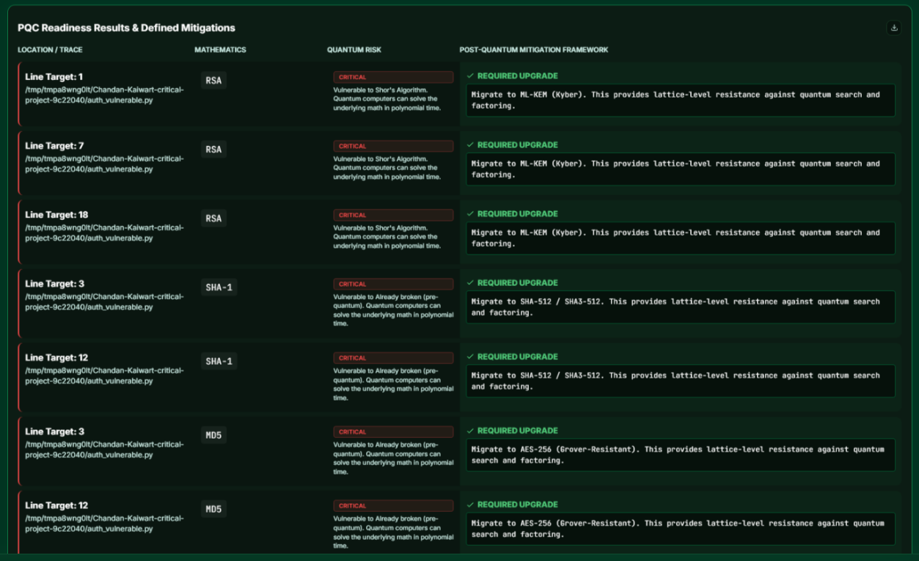
A test file containing explicit references to RSA key generation (RSAPublicKey, rsa_sign, RSA/ECB), ECC parameters (secp256r1, P-256, ECPublicKey), and DSA (DSAPublicKey) was submitted through the Emerald PQC interface. The detector correctly identified all three algorithm families, classified RSA and ECC as quantum-vulnerable under Shor's Algorithm attack, and classified DSA as quantum-vulnerable under the same attack vector. The risk scoring engine assigned a CRITICAL overall risk level due to the presence of multiple asymmetric public-key findings. The recommendation engine produced the following primary outputs: ML-KEM-768 (NIST FIPS 203) as the replacement for RSA and ECC key exchange, ML-DSA-65 (NIST FIPS 204) as the replacement for DSA and ECDSA signatures, and a strategic recommendation to establish a PQC migration task force and implement crypto-agility. The overall readiness percentage returned was 0%, correctly reflecting that no quantum-resistant algorithms were found in the submitted file.
Figure 2: PQCRA — Result of Test
7.2.2 Controlled Test — Mixed Algorithm File
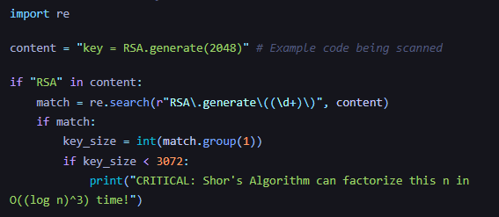
The result of the second test file with a mix of both quantum-vulnerable algorithms (RSA-2048, SHA-1, MD5) as well as quantum-safe algorithms (AES-256, SHA-3, ML-KEM) was received. The detection identified all algorithm families (RSA-2048, SHA-1, MD5, AES-256, SHA-3, and ML-KEM). Due to RSA, SHA-1, and MD5 findings, the risk scoring engine assigned HIGH overall risk and accurately identified that AES-256, SHA-3, and ML-KEM were either secure or already post-quantum secure. SHA-1 and MD5 were designated already broken pre-quantum and were flagged with a CRITICAL-priority recommendation for immediate replacement with SHA-256 or SHA-3-256. AES-256 received confirmation that no immediate action is required. The overall Readiness Percentage is 35%, and this reflects the partial number of quantum-safe algorithms relative to quantum-vulnerable algorithms.
Figure 3: The Classical Weakness: RSA Factorization

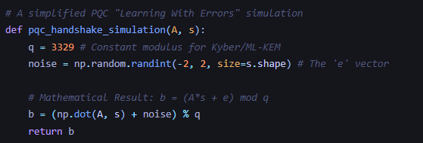
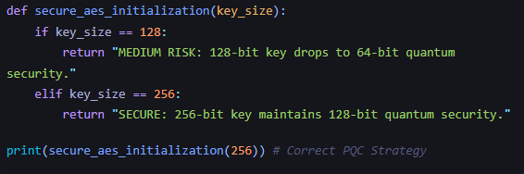
Figure 5: The PQC Solution: Module-Lattice LWE

Figure 4: The Symmetric Dilemma: Grover's Attack on AES

7.2.3 Controlled Test — Clean File
A third test file containing only AES-256 and SHA-3 references — both quantum-resistant — was submitted to verify that the system correctly produces a clean result. The risk scoring engine returned an overall level of MINIMAL with a readiness percentage of 100% and the recommendation message: "No quantum vulnerabilities detected." No migration recommendations were generated, and the results table rendered an empty vulnerability section, confirming that the tool produces no false positives on clean input.
7.3 Evaluation Method
PQCRA's correctness was evaluated using a two-tier approach. The first tier used controlled ground truth inputs — code snippets where every cryptographic identifier was known in advance — and verified the system's output field by field against the expected detection results, risk levels, and recommendations. The second tier used real-world source files from the demo samples directory to verify that the tool produces meaningful and actionable output on realistic input that was not specifically constructed for testing. Across both tiers, the tool correctly detected all seeded algorithm identifiers, assigned appropriate risk levels consistent with the NIST quantum threat model, and produced NIST-aligned migration recommendations for every quantum-vulnerable finding. The deduplication logic was verified to correctly collapse multiple matches of the same algorithm within a five-line window into a single finding, preventing artificial inflation of the vulnerability count.
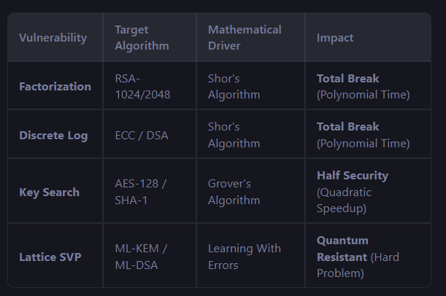
Figure 6: The Basic Concept

- Conclusion
This paper presents PQCRA — Post-Quantum Cryptography Readiness Analyzer — an automated tool designed to scan source code and configuration files, identify cryptographic algorithm usage, assess quantum vulnerability risk, and generate structured NIST-aligned migration recommendations, all without requiring cryptographic expertise from the analyst. Unlike existing manual approaches to cryptographic auditing, which are time-consuming, expertise-intensive, and infeasible at enterprise scale, PQCRA automates the full MODULE from algorithm detection through risk classification and migration guidance in a single web-accessible interface. The tool addresses the precise gap identified by Barker et al. [13] in their NIST evaluation report — the absence of an automated mechanism by which an organisation can objectively evaluate its own post-quantum transition readiness — and delivers a practical decision-support tool that organizations can use to understand their quantum exposure and begin planning their cryptographic migrations.
This research demonstrates that it is possible to create a lightweight, pattern-based cryptographic scanner that can be built wholly with standard, publicly available, open-source Python libraries. It will not rely on binary analysis, symbolic execution, or any machine learning infrastructure, but will still generate actionable, output aligned with the NIST's guidance. The second finding is that the modular four-stage MODULE of the PQCRA — which consists of input ingestion, cryptographic detection, risk scoring, and recommendation generation — provides a mechanism for independently testing, extending, or replacing each component of the system; this makes it easier for the system to adapt as the NIST PQC standardization landscape continues to change and as new algorithms are introduced or old algorithms are no longer being used. The third finding is that the PQCRA generates a human-readable, structured report of readiness by file location, algorithm, quantum risk level, and post-quantum mitigation framework. This means security teams can have a summary of their cryptographic posture that is immediately actionable and does not require significant reverse engineering or any cryptographic expertise to interpret.
The current prototype has several honest limitations that must be acknowledged. PQCRA's detection is pattern-based, which means it can only identify cryptographic algorithms that are explicitly named using recognisable identifiers — obfuscated implementations, dynamically constructed algorithm strings, or cryptographic operations embedded within compiled binaries are not detectable by the current scanning approach.
The risk scoring model utilizes an empirical weighting methodology that incorporates category and key size into the scoring, but that does not account for the entirety of the deployment environment (e.g., implementation of an RSA-2048-based algorithm used to sign test data vs. used to protect live financial transaction data has different risk profiles, but the current scoring framework scores both equally). The recommendation engine uses category-matching to map algorithms to NIST-approved replacements, but does not currently take into consideration performance constraints, interoperability requirements, and/or the library ecosystem of the target system, which are all factors that need to be considered when developing a migration plan. The lack of a publicly available ground truth (i.e., a publicly accessible set of known-vulnerable codebases with validated annotations) limits the measurement of precision and recall metrics against a verified benchmark.
Future work will focus on three primary directions. The first is expanding detection coverage to support binary and compiled file analysis, which would allow PQCRA to scan systems where source code is unavailable — a critical capability for legacy system auditing. The second is integrating dynamic analysis capabilities that can detect cryptographic algorithm usage at runtime through API call interception and system log analysis, complementing the current static pattern-matching approach. The third is adding a confidence scoring layer to the recommendation engine that factors in deployment context, performance requirements, and target platform constraints, transforming PQCRA from a detection and flagging tool into a full migration planning assistant capable of producing environment-specific, prioritised roadmaps for the post-quantum transition.

References
[1] Dominik Dziechciarz and Marcin Niemiec (2025), “Efficiency Analysis of NIST-Standardized Post-Quantum Cryptographic Algorithms”, Electronics, Multidisciplinary Digital Publishing Institute (MDPI), Volume 14, Issue 1, Article 70,
doi: https://www.mdpi.com/2079-9292/14/1/70.
[2] Kandula (2025), “Breaking Traditional Encryption: Quantum Computing Risks to Web and Mobile Applications”,
doi:https://www.researchgate.net/publication/390354758_BREAKING_TRADITIONAL_ENCRYPTION_QUANTUM_COMPUTING_RISKS_TO_WEB_AND_MOBILE_APPLICATIONS.
[3] Filip Opiłka, Marcin Niemiec, et al. (2024), “Performance Analysis of Post-Quantum Cryptography Algorithms for Digital Signature”, Applied Sciences, Multidisciplinary Digital Publishing Institute (MDPI), Volume 14, Issue 11, Article 4994,
doi: https://www.mdpi.com/2076-3417/14/12/4994.
[4] Emils Bagirovs, et al. (2024), “Applications of Post-Quantum Cryptography”, Journal of Information Security and Applications, Elsevier,
doi: https://arxiv.org/pdf/2406.13258.
[5] Gavin Seiler (2024), “Quantum Computing and the Future of Encryption”,
doi:https://www.researchgate.net/publication/387523863_Quantum_Computing_and_the_Future_of_Encryption.
[6] Dekkaki, K. C., Tasic, I., & Cano, M.-D. (2024). Exploring post-quantum cryptography: Review and directions for the transition process. Technologies, 12(12), Article 241. doi: https://doi.org/10.3390/technologies12120241.
[7] Andriy Horpenyuk, Ihor Opirskyy and Petro Vorobets (2023), “Analysis of Problems and Prospects of Implementation of Post-Quantum Cryptographic Algorithms”, CEUR Workshop Proceedings, Volume 3504, Paper 4,
doi: https://ceur-ws.org/Vol-3504/paper4.pdf.
[8] Duc-Thuan Dam, et al. (2023), “A Survey of Post-Quantum Cryptography: Start of a New Race”, Cryptography, Multidisciplinary Digital Publishing Institute (MDPI), Volume 7, Issue 2, Article 40, doi: https://www.mdpi.com/2410-387X/7/3/40.
[9] Neerav Sood (2023), “Cryptography in the Post-Quantum Computing Era”,
doi: https://www.researchgate.net/publication/377696294_Cryptography_in_Post_Quantum_Computing_Era .
[10] Dam, D.-T., Tran, T.-H., Hoang, V.-P., Pham, C.-K., & Hoang, T.-T. (2023). A survey of post-quantum cryptography: Start of a new race. Cryptography, 7(3), Article 40.
doi: https://doi.org/10.3390/cryptography7030040.
[11] Manish Kumar (2022), “Post-Quantum Cryptography Algorithm’s Standardization and Performance Analysis”, Array, Elsevier, Volume 15, Article 100242,
doi: https://doi.org/10.1016/j.array.2022.100242.
[12] Sherdel A. Käppler and Bettina Schneider (2022), “Post-Quantum Cryptography Challenges in Society 5.0”, Society 5.0 Conference Proceedings,
doi: https://easychair.org/publications/paper/z7P1.
[13] William Barker, et al. (2021), “Getting Ready for Post-Quantum Cryptography”, NIST Cybersecurity White Paper, National Institute of Standards and Technology (NIST),
doi: https://doi.org/10.6028/NIST.CSWP.04282021.
[14] Crystal Roma, et al. (2021), “Energy Efficiency Analysis of Post-Quantum Cryptographic Algorithms”, SN Applied Sciences, Springer Nature, Volume 3, Article 684,
doi: https://www.researchgate.net/publication/351708179_Energy_Efficiency_Analysis_of_Post-Quantum_Cryptographic_Algorithms.
[15] Kazutoshi Kan and Masashi Une (2021), “Recent Trends on Research and Development of Quantum Computers and Standardization of Post-Quantum Cryptography”,
doi:https://www.imes.boj.or.jp/research/papers/english/21-E-05.pdf .
[16] Tiago M. Fernández-Caramés and Paula Fraga-Lamas (2020), “Towards Post-Quantum Blockchain: A Review on Quantum-Resistant Distributed Ledger Technologies”, Sensors, Multidisciplinary Digital Publishing Institute (MDPI), Volume 20, Issue 4, Article 1248,
doi: https://arxiv.org/pdf/2402.00922.
[17] Mohammed Ahmed (2018), “Quantum-Resistant Cryptography”,
doi: https://www.researchgate.net/publication/390626837_Quantum-Resistant_Cryptography_Advancing_Encryption_to_Withstand_Quantum_Threats.
[18] Ruben Niederhagen and Michael Waidner (2017), “Practical Post-Quantum Cryptography”, Fraunhofer SIT White Paper,
doi: https://www.sit.fraunhofer.de/fileadmin/dokumente/studien_und_technical_reports/Practical.PostQuantum.Cryptography_WP_FraunhoferSIT.pdf.
[19] Lily Chen, Stephen Jordan, Yi-Kai Liu, Dustin Moody, Ray Perlner and Daniel Smith-Tone (2016), “Report on Post-Quantum Cryptography (NIST IR 8105)”, NIST Internal Report, National Institute of Standards and Technology,
doi: https://doi.org/10.6028/NIST.IR.8105.
[20] Katherine Fisher, et al. (2014), “Quantum Computing on Encrypted Data”, Physical Review Letters, Volume 112, Issue 4,
doi: https://arxiv.org/abs/1309.2586.

